PERSONAL FINANCE APP

UI/UX Project Documentation
Team: 6 members
A24126510145: LANDA PRUDHVI RAJ
A24126510147 : MEESALA ARUNA
A24126510148 : MERIGALA SRIMANTH
A24126510149 : MODI SRAVANI
A24126510150 : NALLAM SAI GANESH
A24126510 268: GOLLAPALLI HASINI

Tool: Figma
Project: Personal Finance App helps users track expenses, manage budgets, and monitor savings through an intuitive and visually engaging interface.

Table of Contents

1. Project Overview
2. Tools &amp; Plugins
3. Process Overview
4. Design System &amp; Assets
5. Component Library &amp; Variants
6. Frame-by-Frame: how each screen was built
7. Prototyping &amp; Animation details
8. Auto-layout &amp; responsive rules used

1]Project Overview:

Financius is a personal finance management mobile application designed to help users take control of their finances with ease and confidence. The app provides users with intuitive tools to track expenses, set budgets, monitor savings goals, and analyze spending habits through visual insights and smart recommendations.

The design focuses on simplicity, accessibility, and visual clarity, enabling users to understand their financial health at a glance.

2]Tools and Plugins:
- Figma (desktop/web) — design & prototype
- Plugins: Iconify, color layout.
- Figma built-in: Auto Layout, Components, Variants, Smart Animate

3]Process Overview:
PHASE 1 — Planning & Research: Defined target users, created personas, identified key pain points, and finalized core features.
PHASE 2 — Wireframing: Built low-fidelity wireframes to outline app structure, navigation, and information flow.
PHASE 3 — Visual Design: Applied color palette, typography, and brand elements to create high-fidelity screens.
PHASE 4 — Components & Reusability: Developed a consistent component library with variants for scalable design.
PHASE 5 — Prototyping & Animation: Connected screens, added transitions, and micro-interactions for realistic user experience.
PHASE 6 — User Testing & Feedback: Conducted usability testing, gathered feedback, and refined user flows for clarity.
PHASE 7 — Submission & Handover: Prepared final design files, documentation, and shared assets for developer handoff.

4]Design System & Assets
Color Palette:
The app adopts a dark-themed interface for a sleek, modern appearance, ensuring high contrast and easy readability. Bright accent colors like green, red, and blue highlight financial data clearly, helping users distinguish between income, expenses, and actions quickly.
Primary Gradient: Green → Blue (for headers and CTA highlights)
Green Base: #00C853
  - Blue Base: #2962FF
- Primary Solid (Alternate): #00A86B (for key action buttons like Submit or Add Income)
- Neutral Backgrounds:
  - Dark Base: #1C1C1E
  - Secondary Grey: #2C2C2E
  - Card Surface: #3A3A3C
- Text Colors:
  - Primary: #FFFFFF
  - Secondary: #B0B0B0
- Accent Colors:
  - Red: #FF2D55 (for expenses, alerts)
  - Green: #00FF66 (for income, confirmations)
Implementation Tip:
All colors are saved as Figma Color Styles with naming such as:
Primary / Gradient-Start / Gradient-End / Background / Secondary-Text / Accent-Red / Accent-Green.

Typography
The type system emphasizes clarity and readability, maintaining a consistent structure across all screens. The mix of Poppins and Roboto creates balance—bold titles for clarity and clean body text for simplicity.
- Headings: Poppins Bold — 20–28 px
- Subheadings: Poppins Medium — 16–18 px
- Body Text: Roboto Regular — 14 px
- Caption / Micro Text: Roboto Regular — 12 px
Usage Example:
- “Add Transaction” → Heading (H1)
- “Monthly Budget” → Subheading (H2)
- Transaction details and labels → Body
- Date and notes → Caption
Save these as Figma Text Styles: H1, H2, Body, Caption.
5]Component Library & Variants
1. Primary Button Component
The Primary Button is used for all main actions such as Add Income, Add Expense, Run Backup, and Restore Data.
It maintains a consistent shape, padding, and typeface throughout the app.
- Variants: Default / Pressed / Disabled
- Properties:
  - Auto-layout padding: 16px (horizontal), 12px (vertical)
  - Corner radius: 12px
  - Typography: Poppins Medium, 16px, White (#FFFFFF)
  - Colors:
    - Green (#00A86B) for confirmation or income
    - Red (#FF2D55) for delete or expense
2. Bottom Navigation Bar
A persistent navigation bar helps users move seamlessly across main sections — Home, Add, Reports, and Settings.
Each icon is an instance component linked to the active page.
- Variants: Home Active / Add Active / Reports Active / Settings Active
- Design:
  - Active icon: Green (#00FF66)
  - Inactive icon: White (#FFFFFF)
  - Label text below each icon
The Transaction Card component displays individual records in the “All Transactions” screen.
- Variants: Income / Expense
- Layout:
  - Category icon → Transaction title → Amount → Status tag
  - Amount color-coded: Green (income), Red (expense)
  - Auto-layout with 16px internal padding
4. Dashboard Summary Card
Used in the Home Screen, these cards display financial overviews such as Total Income, Total Expense, and Remaining Balance.
- Variants: Income / Expense / Balance
- Design:
  - Clean gradient background (Green → Blue)
  - Label, amount, and progress indicator
5. Input Field Component
The Input Field is used in forms such as Add Transaction and Settings.
- Variants: Empty / Focus / Error
- Properties:
  - Rounded corners (8px)
  - Background: Neutral gray (#1F1F1F)
6. Toggle Switch
Used in the Cloud Sync section to manage backup settings.
- Variants: On / Off
- Design:
  - Circular handle
  - Green active state indicator
  - Smooth prototype animation
7. Modal / Popup
Used for displaying confirmation, success, or error messages such as Backup Complete or Error Restoring Data.
- Variants: Success / Warning / Error
- Design:
  - Rounded corners (12px)
8. Category Icon Set
A library of custom icons representing transaction types like Food, Travel, Groceries, Salary, and Shopping.
- Variants: Active / Inactive
- Colors: Green for active selection, Gray for inactive
- Use Case: Add Transaction category selection screen
This component adds personality and easy recognition to financial entries.
6]Frame-by-Frame — EXACTLY how each screen was built
Frame 1 — Splash (Logo)
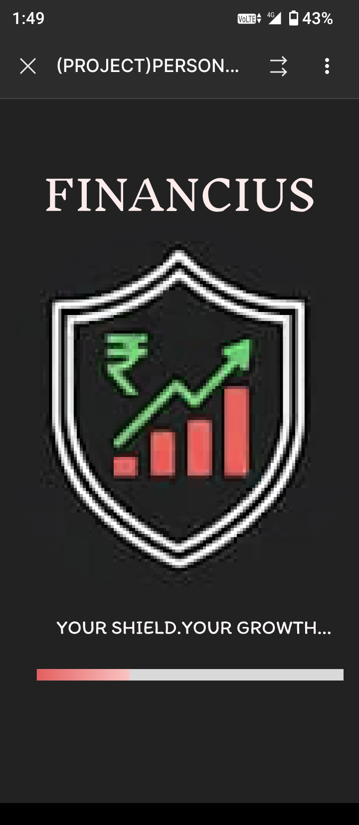
Purpose: Brand entry — reinforce app identity and set tone.
Key components: App Logo (shield + graph), background (dark).
User actions: None (automatic).
Micro-interactions / Transition: Short fade-in of logo → progress bar under logo fills → auto-transition to Frame 2.
Notes: Keep splash duration ~1.5s; use subtle scale-up on logo for polish.
Steps to Create:
- Create a new Figma Frame (size: 390×844 or standard mobile size).
- Set background to dark (#0D0D0D).
- Place app logo (vector or image) at the center.
- Add the app name “FINANCIUS” below logo (Poppins Bold, 24px, white).
- Create a small loading/progress bar under it using rectangles.
- Apply Prototype → After delay (1500ms) → Navigate to Frame 2 for auto-transition.
Frame 2— Login / Welcome .
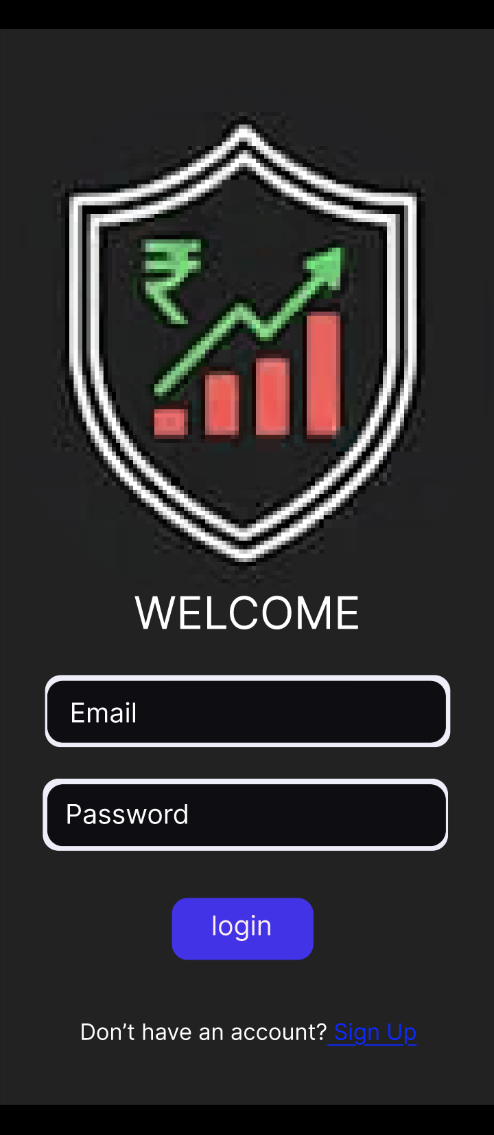
Purpose: User authentication.
Steps to Create:
- New frame → Background: neutral #FFFFFF or dark theme if consistent.
- Add logo at top, spacing 32px from header.
- Create two Input Field Components (Email, Password).
- Below inputs, place the Primary Button (Login) with Auto-Layout.
- Add secondary link “Don’t have an account? Sign Up.”
- Prototype: Login button → Navigate to Dashboard (Frame 4).
Result: Simple and clear login screen using consistent component styles.

Frame 3 — Dashboard / Home

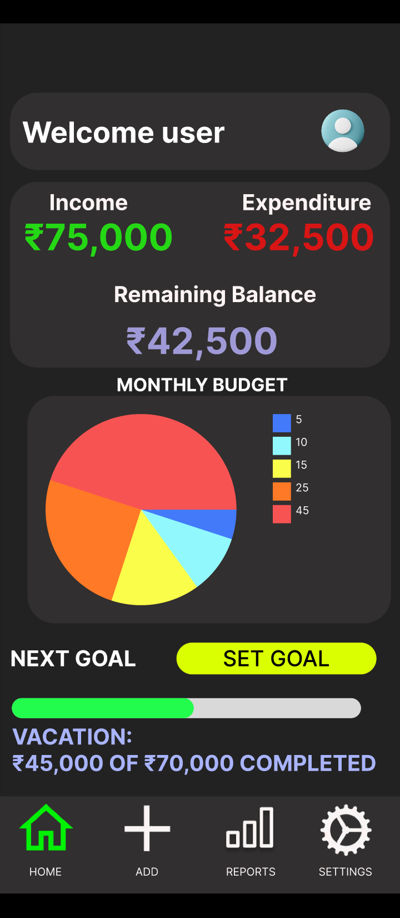
Purpose: Display main financial overview.
Steps to Create:
- Frame background: #F5F6F8.
- Add Dashboard Summary Cards (Income, Expense, Balance) using Auto-Layout vertically.
- Insert a circular or bar progress element for monthly goal.
- Add a simple bar or line chart for quick insight.
- Fix Bottom Navigation Component at bottom.
- Prototype bottom nav icons to link to Frames 5, 8, and 9.
Result: Main home interface showing overall income and expenses with visual summaries.
Frame 4— Add (Transaction Selector)
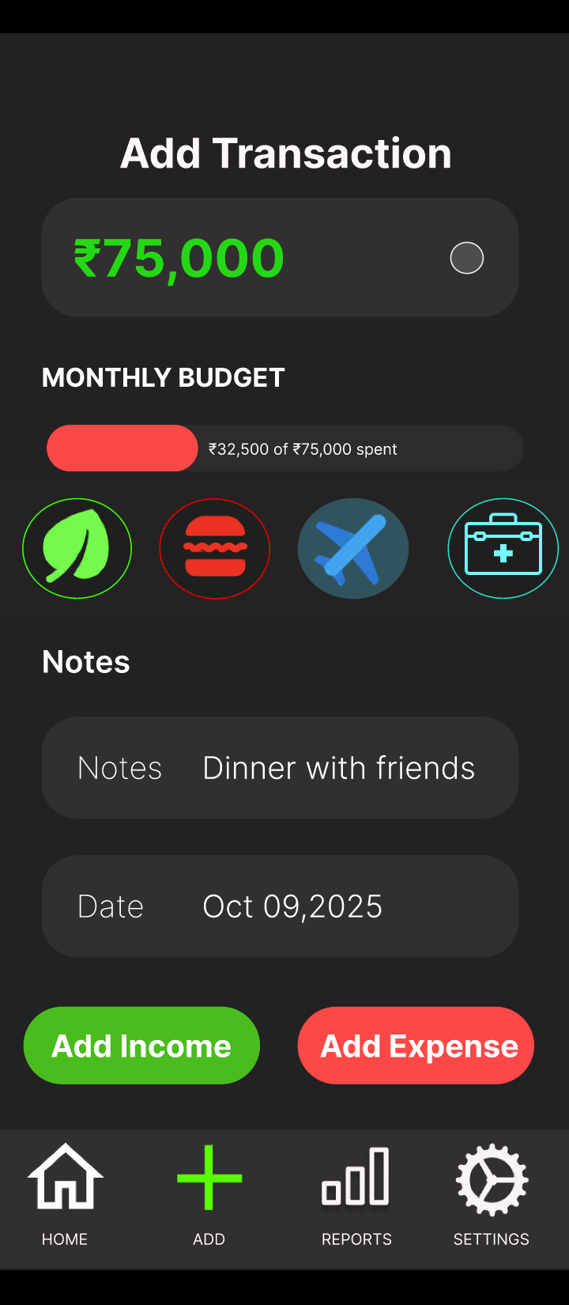

Purpose: Select whether to add income or expense.
Steps to Create:
- New frame → Background same as Dashboard.
- Add heading: “Add Transaction.”
- Place two Primary Buttons: Add Income (green) and Add Expense (red).
- Include small category icons row for quick selection.
- Prototype:
  - Add Income → Frame 6 (Add Transaction Form)
  - Add Expense → Frame 6 (with variant switch for red accent).
Result: Minimal and quick entry hub to add transactions.
Frame 5 — Add Transaction (Form)
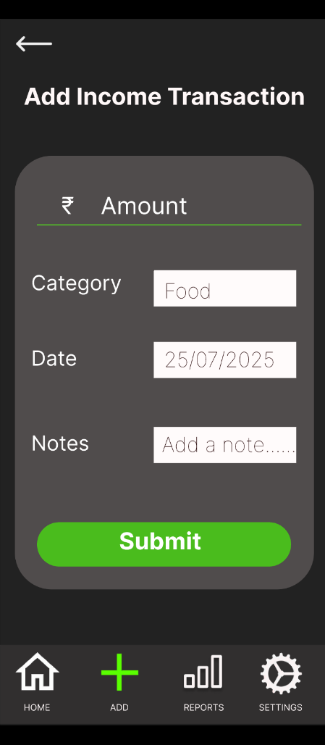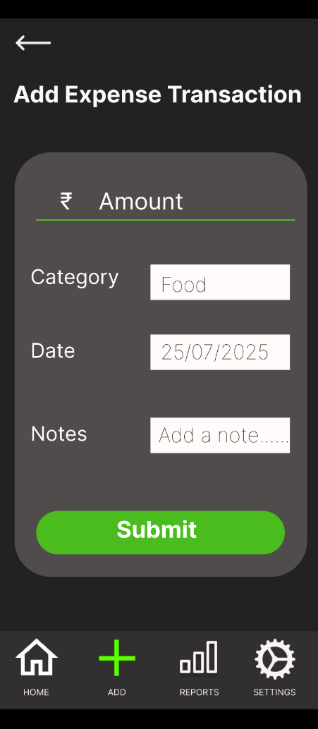
Purpose: Capture detailed transaction input.
Steps to Create:
- Frame background: #FFFFFF.
- Add Input Fields for Amount, Category, Notes, and Date.
- Use Category Icon Components horizontally (Food, Travel, Salary, etc.).
- Insert a small progress bar on top to show budget utilization.
- Place two buttons at the bottom: Add Income (green) and Add Expense (red).
- Prototype success state → small success modal (Frame 10) → return to Dashboard (Frame 4).
Result: Interactive and functional data entry screen.

Frame 6 — All Transactions (List):

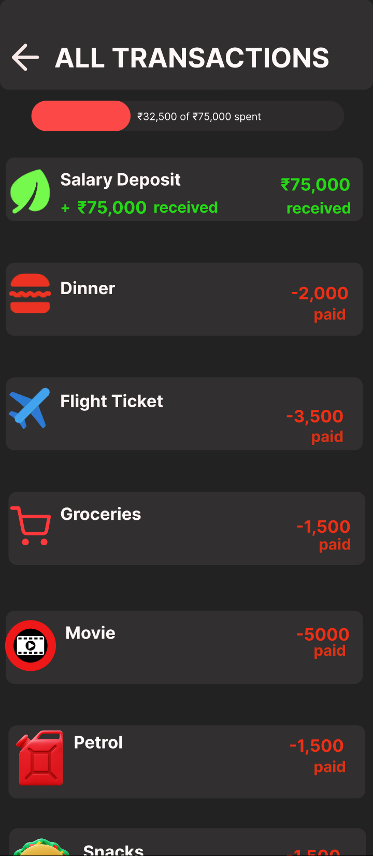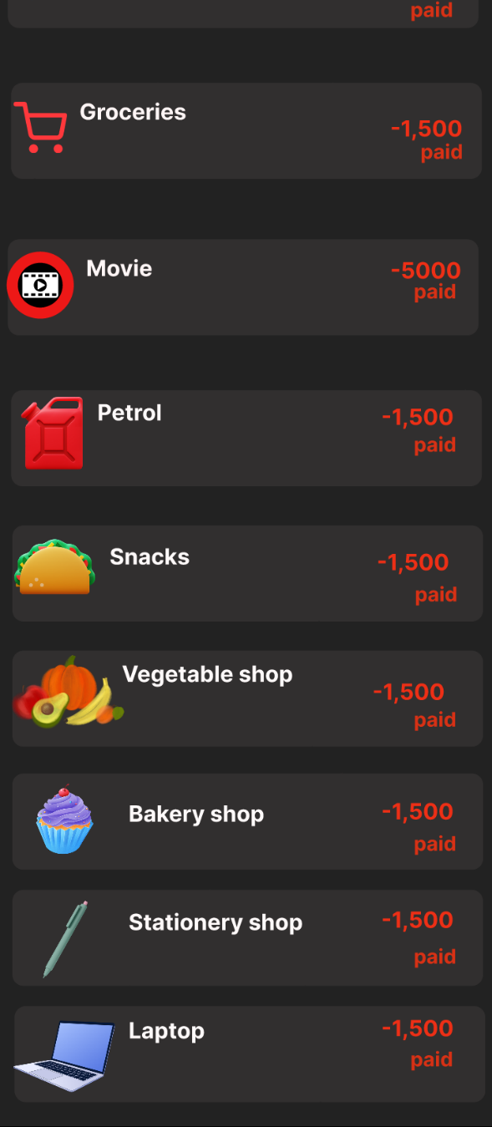
Purpose: View all past transactions.
Steps to Create:
- Create repeating Transaction Card Components (using Auto-Layout).
- Add category icon, title, amount (color coded), and small tag for status.
- Scroll container (enable vertical scrolling in Figma prototype).
- Add top summary bar (total spent / earned).
- Prototype each card → tap → expand details (optional variant).
Result: Organized transaction history that is easy to scan and manage.
Frame 7 — Reports / Analytics
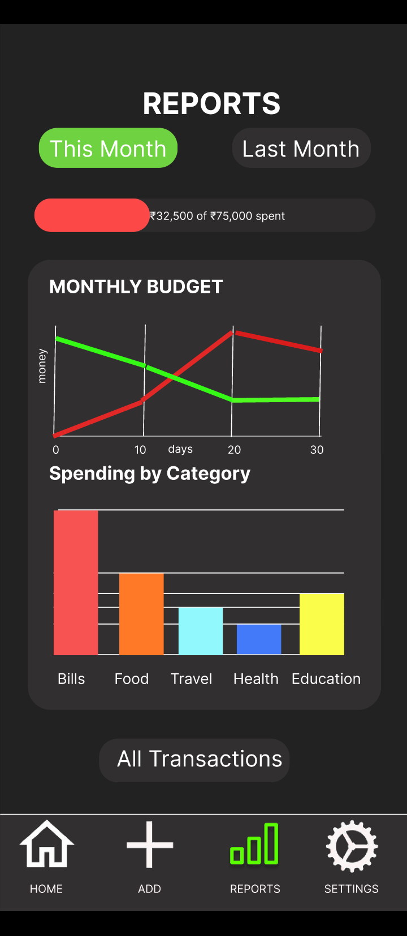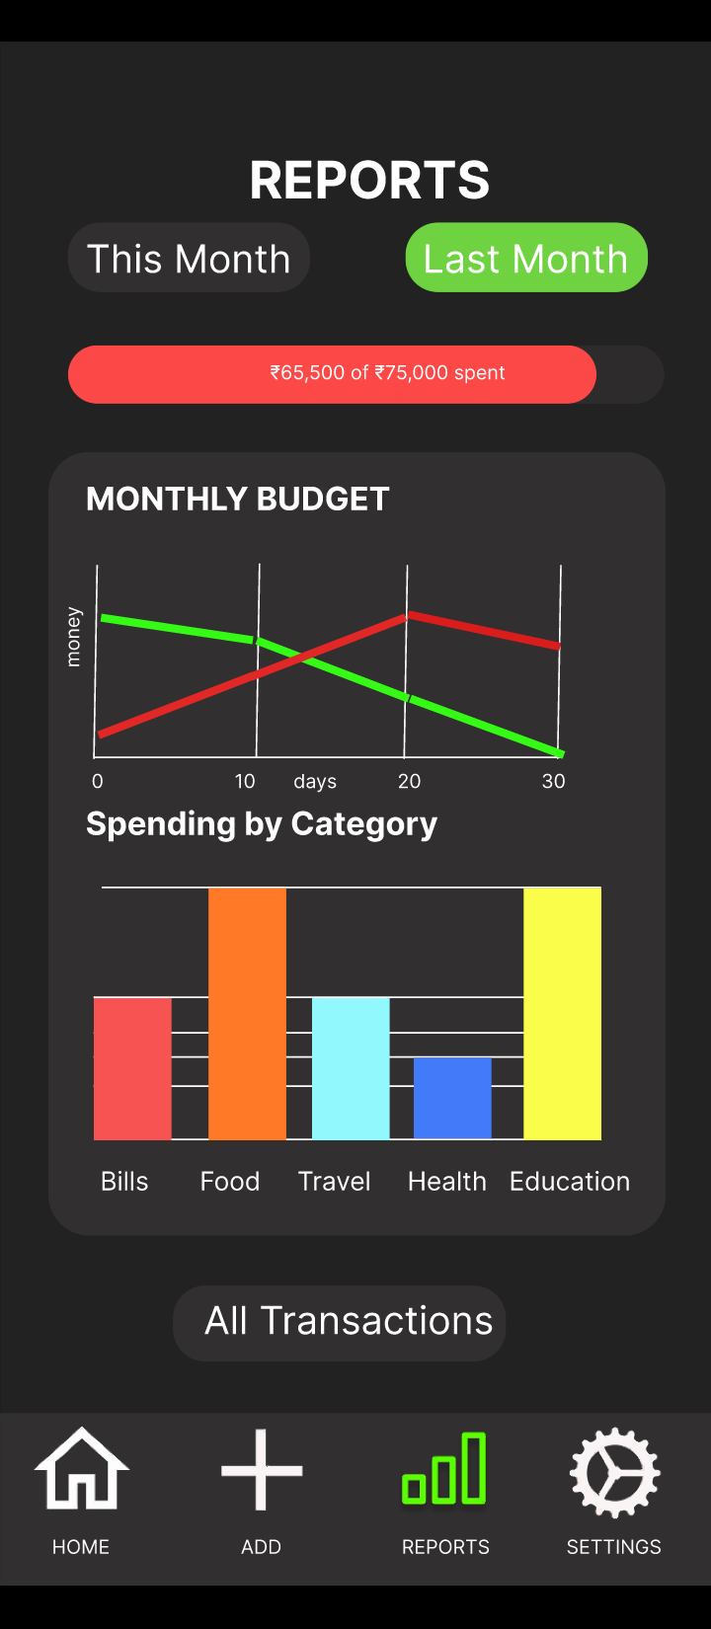
Purpose: Show visual spending insights.
Steps to Create:
- Add a top title “Reports & Analytics.”
- Insert bar chart (spending by category) and line chart (income vs expense).
- Use neutral background and accent colors (Green → Blue gradient).
- Include filter tabs (“This Month”, “Custom”) made as button variants.
- Add share/export button at top right.
Result: Interactive analytics page with clear financial visualization.
Frame 8— Settings / Cloud Sync
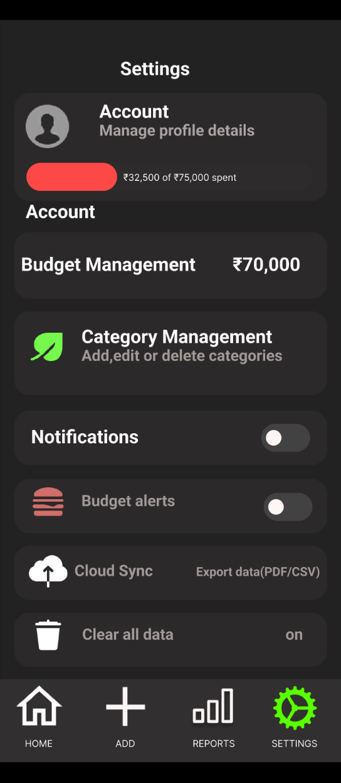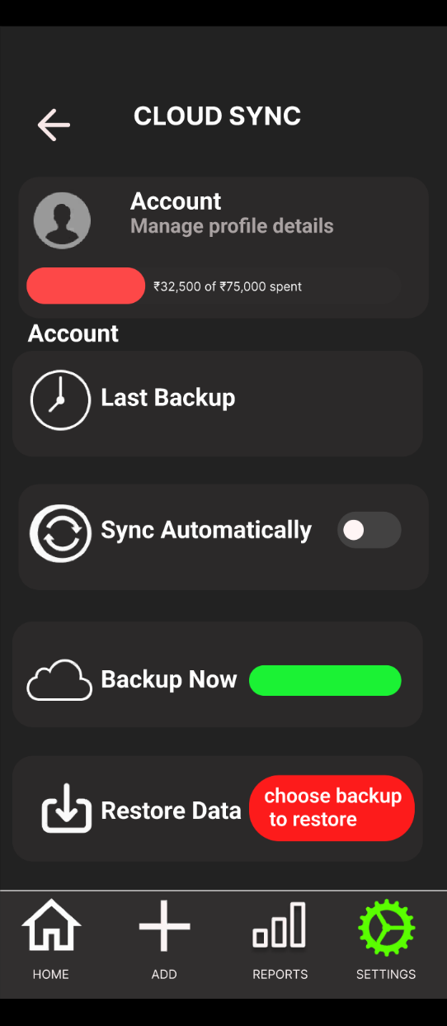
Purpose: Manage backups, restore data, and sync settings.
Steps to Create:
- Frame background: #F5F6F8.
- Add header “Cloud Sync & Settings.”
- Create rows for Profile, Last Backup, and Storage Info.
- Insert Toggle Component (Auto-Sync: On/Off).
- Add Primary Buttons: Run Backup and Restore Data.
- Prototype “Run Backup” → Modal (Frame 10).
Result: Functional settings screen for user data safety and control.
Frame 9-Account Details
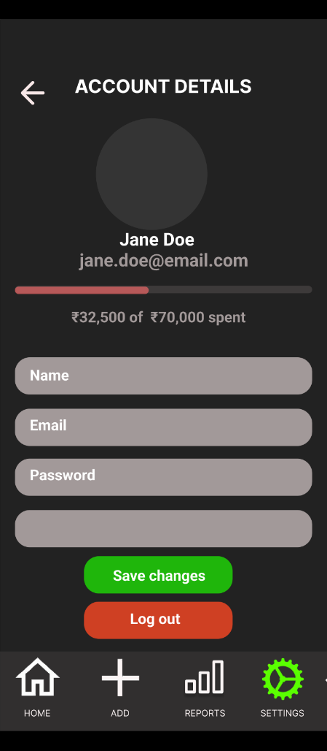
Purpose:
Let users view and edit their account details and spending info.
Steps to Create:
- Set dark background #1E1E1E.
- Add header “Account Details” with back arrow.
- Insert profile circle, name, and email text.
- Add spending progress bar and amount text.
- Create input fields for Name, Email, and Password.
- Add buttons — Save Changes (Green) and Log Out (Red).
- Add bottom navigation with Home, Add, Reports, Settings icons.
Result:
Simple, clear screen to manage account info and spending.

7]Prototyping & Animation — Implementation Details

Prototype Flow
Starting Frame:
Set Frame 1 — Splash as the starting point of the prototype.
Interaction Mapping:
- Splash (Delay 1000ms) → Login Screen (Auto Navigate).
- Login → Dashboard: On Tap Login Button, Navigate to Dashboard (Smart Animate).
- Sign Up → Create Account → Dashboard: Smooth step flow for first-time users.
- Dashboard → Add Transaction: On Tap Add (+) Button, Navigate to Add Screen (Slide Up).
- Add Transaction → All Transactions: On successful Add, Smart Animate to transaction list.
- Dashboard → Reports: Tap Reports Icon in bottom navigation → Navigate to Reports frame.
- Dashboard → Settings: Tap Settings Icon → Navigate to Cloud Sync screen.
- Settings → Modal (Backup/Restore): Tap Run Backup / Restore Data, open modal overlay (Slide Up).
- Modal → Settings: On Confirm or Cancel → Close Overlay / Navigate back.
This flow ensures smooth user navigation across all key functions — tracking, adding, analyzing, and managing financial data.

Button & Interaction Micro-Animations
Purpose: Enhance user engagement and provide visual feedback.
Implementation:
- All Primary Buttons have Pressed Variants with slight shadow reduction and scale-down (0.97).
- Disabled Variant: Lower opacity (60%) and color set to #A8A8A8.
- Navigation Icons: Active icon changes to gradient (Green → Blue), label becomes bold.
- Hover (Desktop Preview): Subtle shadow elevation using Smart Animate.

Like / Bookmark Animation (Detailed Example)
Method: Smart Animate between component variants.
Steps:
- Create Transaction_Unbookmarked variant: bookmark icon outlined, scale 0.9.
- Duplicate and rename Transaction_Bookmarked: icon filled (#00C853), slight scale-up (1.2), with small spark or highlight effect.
- In Prototype:
  - On Tap → Navigate to Bookmarked Variant.
  - Animation: Smart Animate, Easing: Ease Out, Duration: 350ms.
- Reverse interaction:
  - On Tap (Bookmarked) → Navigate back to Unbookmarked Variant (same animation).
This creates a satisfying micro-interaction when users mark important transactions or goals.

Overlays & Modals
Use Case: Confirmation dialogs, share actions, or comment overlays.
Implementation:
- Backup / Restore Modal:
  - Create a smaller centered frame with white background (#FFFFFF) and rounded corners (12px).
  - Set interaction: Open Overlay, Position: Center, Animation: Dissolve (200ms).
  - Include two buttons — Confirm and Cancel — linked to next actions.
- Bottom Sheet for Quick Actions:
  - Used in Add Transaction or Reports filters.
  - Use Open Overlay, anchored to Bottom, Animation: Slide Up (300ms).
- Toast Notification:
  - Small rectangle with text “Transaction Added Successfully!”
  - Animate Fade In → Delay (1500ms) → Fade Out.

Transitions Between Frames
Navigation Animations:
- Splash → Login: Dissolve (1000ms) — gentle fade for startup transition.
- Login → Dashboard: Smart Animate (Ease Out, 500ms) — smooth entry to main app.
- Dashboard → Add Transaction: Slide Up (400ms) — quick action transition.
- Dashboard → Reports: Push Left (300ms) — simulates tab navigation.
- Dashboard → Settings: Push Right (300ms) — consistent back navigation.
- Add Transaction → All Transactions: Smart Animate (Ease In-Out, 400ms) — for continuity.
- Settings → Modal: Open Overlay (Slide Up) for contextual confirmations.

Auto Layout & Smart Animate Notes
- Ensure consistent Auto Layout padding (16px) and corner radius (12) across components for seamless Smart Animate behavior.
- For any property to animate (color, size, opacity), both frames or component variants must have matching layer names and hierarchy.
- Use “Match Layers by Name” setting in Smart Animate to avoid flickering transitions.

Prototype Preview Optimization
- Enable “Smart Animate Matching Layers” in prototype settings.
- Set Device Frame to standard (e.g., iPhone 14) for realistic display.
- Use Overflow Scrolling (Vertical) for transaction lists.
- Add simple Swipe Gestures: e.g., Swipe Left on a transaction to delete or favorite (optional).

Outcome
The prototype successfully replicates a smooth, real-app experience — transitions are fluid, feedback animations feel responsive, and overlays enhance usability without clutter.
Users can intuitively navigate through adding, viewing, and analyzing their finances while subtle micro-animations make the interface feel dynamic and engaging.

8. Auto-layout & Responsive Rules (How We Used It)

Auto-layout Usage
To ensure all screens in the FINANCIUS app remain consistent and adaptable across devices, Auto-layout was applied to key interface groups and components throughout the design.
Auto-layout was used for:
- Header Sections – Each header (e.g., Dashboard title, Profile info, Settings bar) combines the avatar, username, and action icons in a horizontal auto-layout.
  - Alignment: Center vertically
  - Spacing between elements: 12–16px
- Summary & Feed Cards – Cards such as Income/Expense summaries and transaction cards are structured in a vertical auto-layout.
  - Contain elements like title → value → date/notes
  - Internal padding maintained uniformly (16px)
- Action Rows – Used in sections like “Add Transaction” and “Feed actions” (like, comment, share).
  - Horizontal layout with evenly spaced icons
  - Icons center-aligned for balance
- Bottom Navigation Bar – Designed using horizontal auto-layout with equal spacing between all four icons (Home, Add, Reports, Settings).
  - Icons and labels grouped with consistent padding (8px)
  - Bar fixed to the bottom using constraints
- Input Groups – Form fields (Amount, Category, Date, Notes) in “Add Transaction” screen use vertical auto-layout, ensuring fields resize evenly and maintain uniform gaps.

Benefits of Using Auto-layout
Using Auto-layout across FINANCIUS streamlined the workflow and improved both design accuracy and scalability.
Key benefits:
- Consistent Spacing: When text size or content length changes (e.g., long category names), layout adjusts automatically without breaking alignment.
- Component Flexibility: Updating padding, button size, or typography updates all instances across the design.
- Responsive Adjustments: Elements expand or shrink proportionally on different screen sizes.
- Design Efficiency: Simplifies duplication of cards and screens while maintaining consistent visual hierarchy.
- Cleaner Handoff: Developers can easily interpret spacing, alignment, and constraints from organized Auto-layout structures.

